Exercise 26: Setting up MongoDB Atlas Cloud Database

Objective
In this exercise, you’ll learn about MongoDB Atlas that is a fully-managed cloud database service provided by MongoDB. It offers an easy way to host and manage your MongoDB databases in the cloud, removing the complexity of database administration. MongoDB Atlas provides a range of features and benefits for developers and businesses looking to leverage the power of MongoDB in a cloud environment.

Setup MongoDB Atlas

Rigister and Log in to Atlas.
- Rigister Atlas account at https://www.mongodb.com/cloud/atlas/register
- Complete any welcome prompts. If you're logging in for the first time, Atlas sometimes skips the next two steps.
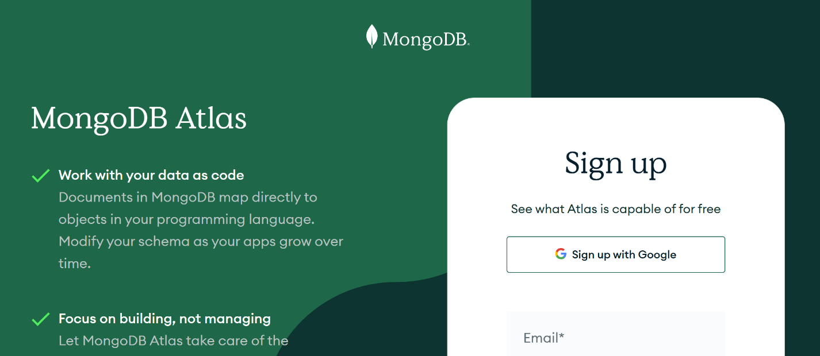
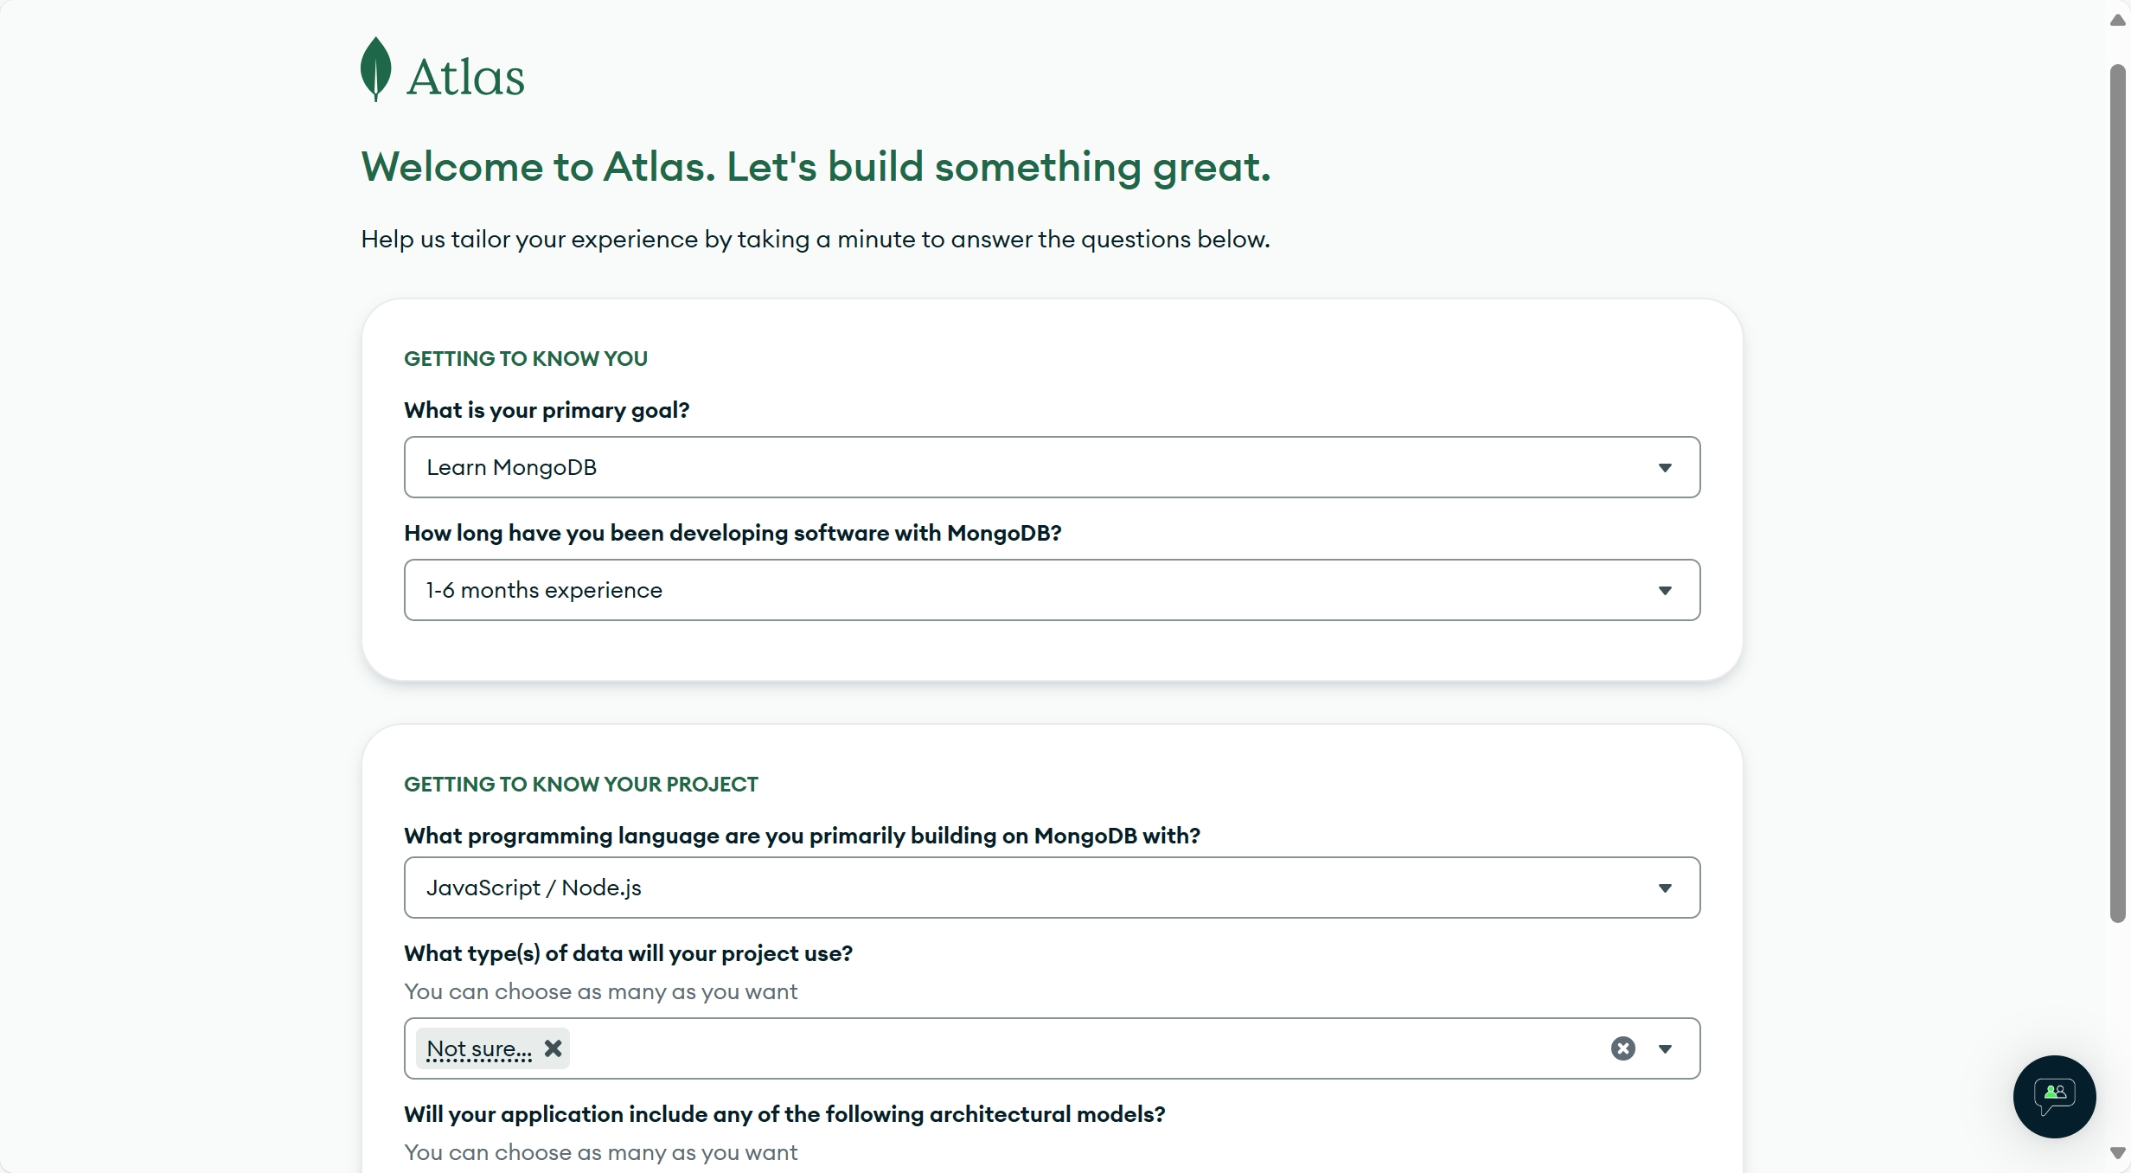

Go to the Overview page for your project.
- If it is not already displayed, select the organization that contains your desired project from the Organizations menu in the navigation bar.
- New project in Mongo Atlas
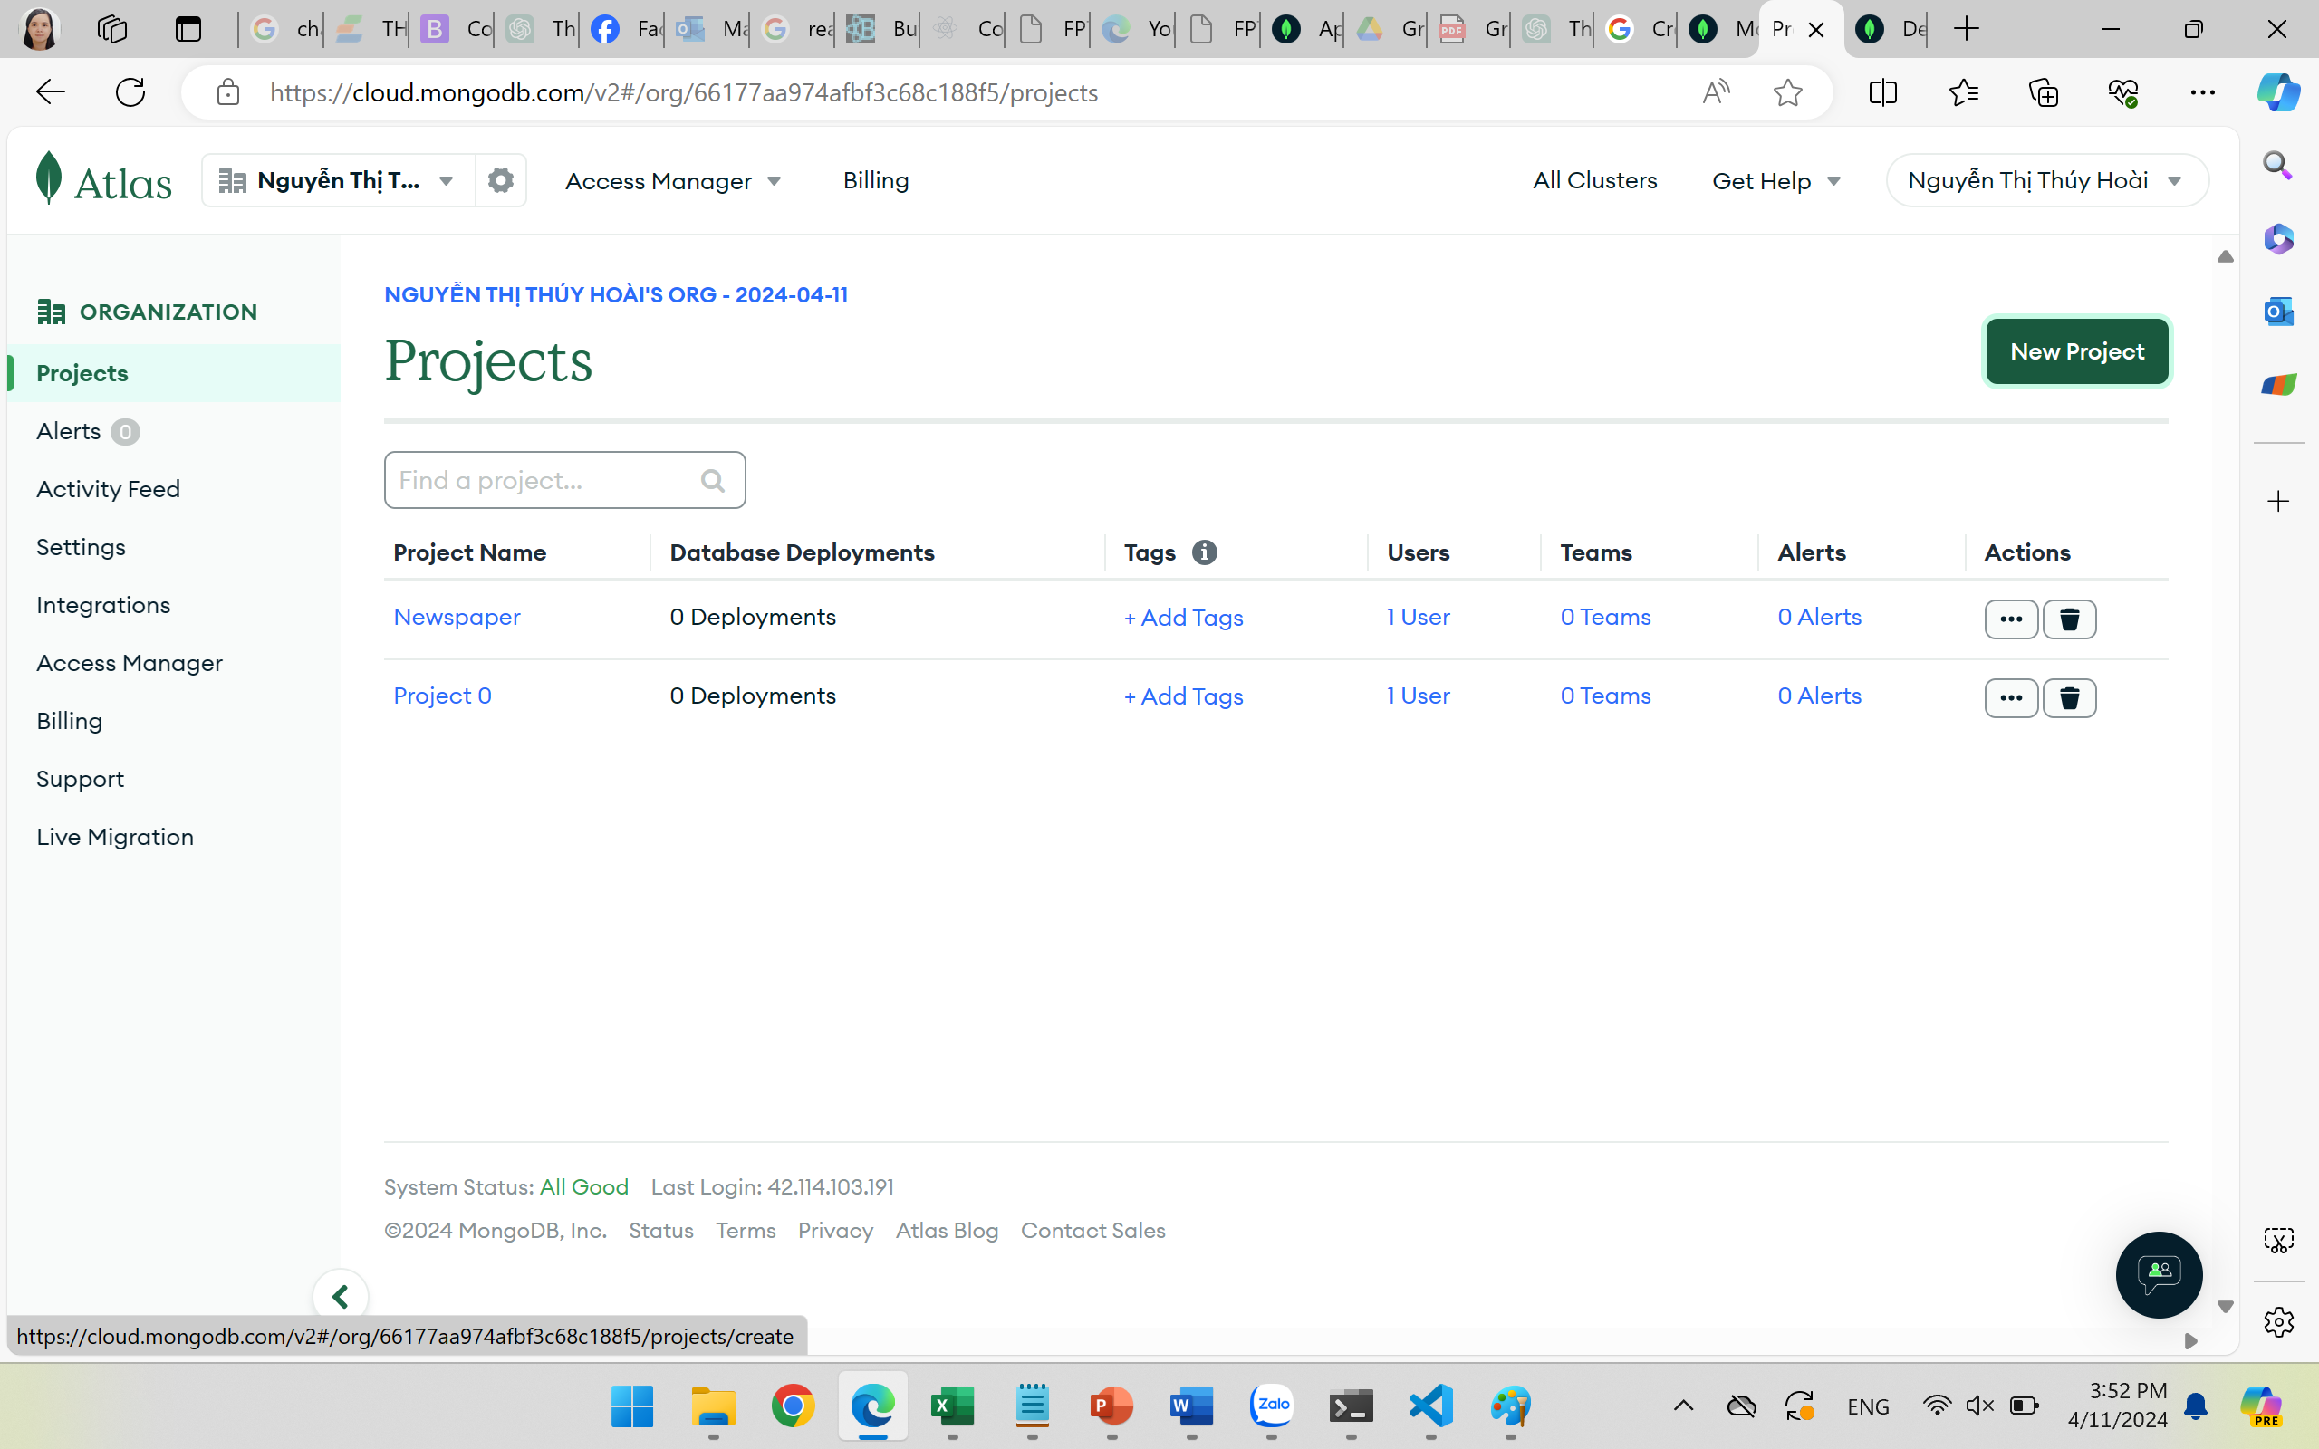
- If it is not already displayed, select your desired project from the Projects menu in the navigation bar.
- If the Overview page is not already displayed, click Overview in the sidebar.

Create a cluster.
- Click the Create button to create a cluster.
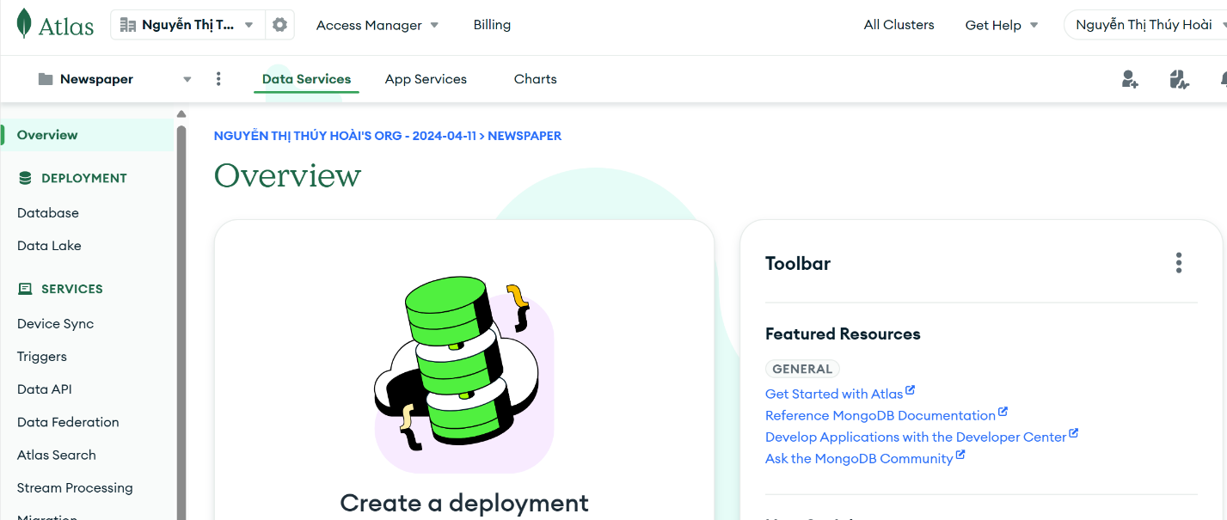

Select the M0 option.
- M0 clusters are free forever and suitable for users learning MongoDB or developing small proof-of-concept applications.

Select your preferred Provider.
- Atlas supports M0 free clusters on Amazon Web Services (AWS), Google Cloud Platform (GCP), and Microsoft Azure.

Select your preferred Region.
- Atlas displays only the cloud provider regions that support M0 free clusters.

Specify a name for your cluster in the Name box.
- You can specify any name for your cluster. The cluster name can contain ASCII letters, numbers, and hyphens.

- You can't change the cluster name after Atlas deploys the cluster. Cluster names can't exceed 64 characters in length.

Click Create to deploy the cluster.
- The Security Quickstart wizard appears.
- To learn more about the security features available, see Configure Security Features for Database Deployments.
- Once you deploy your cluster, it can take up to 10 minutes for your cluster to provision and become ready to use.
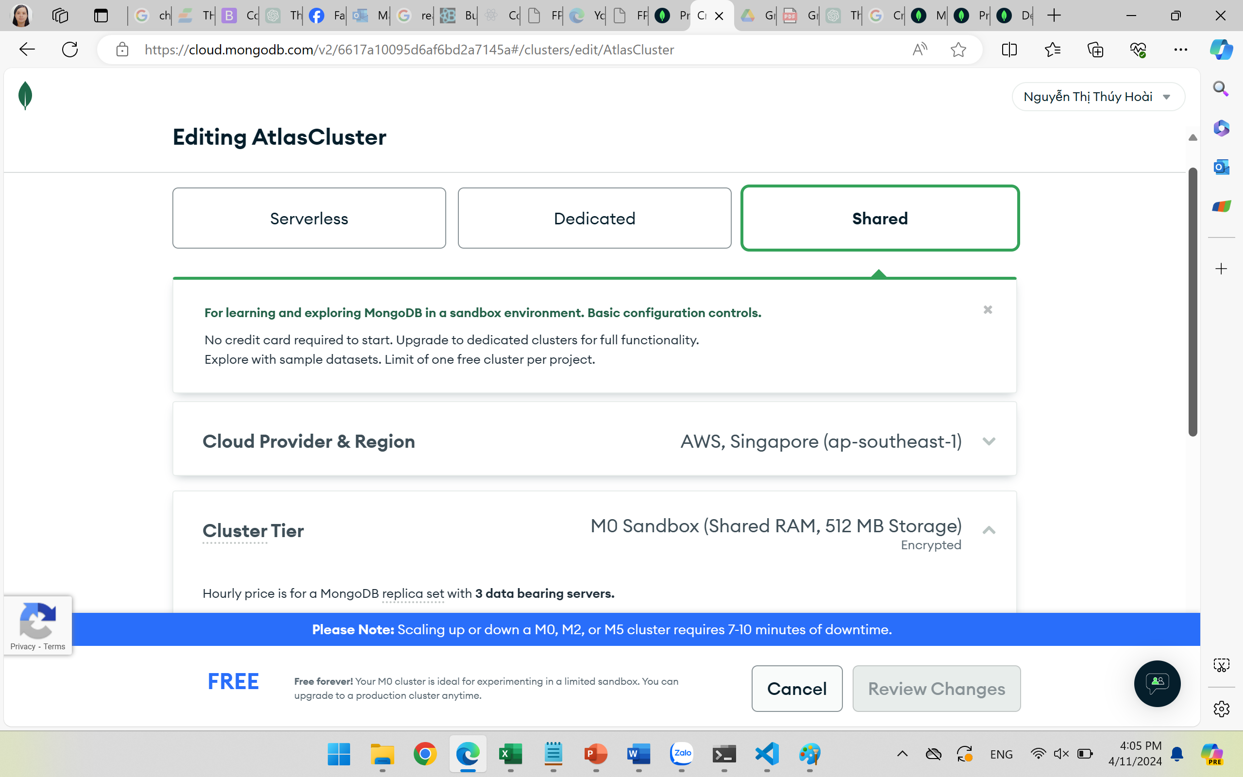

Create a database user.
- Specify a Username for your database user.
- Specify a Password or copy the secure password that Atlas suggests.
- Click Create Database User.

Add your IP address to the IP access list.
- Click Add My Current IP Address.
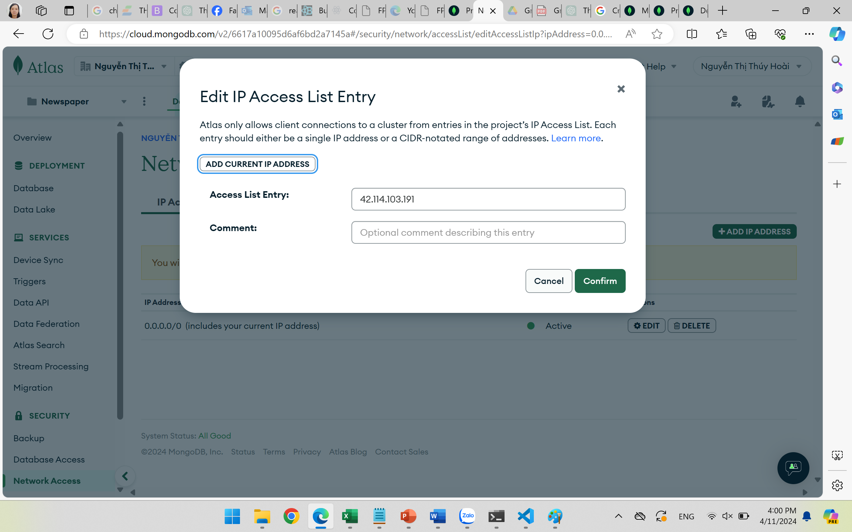
- Click Finish and Close.
- Click Go to Overview.

Conclusion
After doing this exercise,

